ICEngineSoft Test Report

Report Date : Sat, Apr 8, 2023 , Time : 9:39:34 PM
Organization : Organisation, Operator : Operator
Data File : 08-04 T20D80+H2 6LPM.xlsx, Last Modified Date: Sat, Apr 8, 2023,
Config. File : Kirloskar TV1 Engine.xls

Engine Details :

ICEngine set up under test is Kirloskar TV1 having power 5.20 kW @ 1500 rpm which is 1 Cylinder, Four stroke , Constant Speed, Water Cooled, Diesel Engine, with Cylinder Bore 87.50(mm), Stroke Length 110.00(mm), Connecting Rod length 234.00(mm), Compression Ratio 17.50, Swept volume 661.45 (cc)

Combustion Parameters :

Specific Gas Const (kJ/kgK) : 1.00, Air Density (kg/m^3) : 1.17, Adiabatic Index : 1.41, Polytrophic Index : 1.09, Number Of Cycles : 10, Cylinder Pressure Referance : 6, Smoothing 2, TDC Reference : 0

Performance Parameters :

Orifice Diameter (mm) : 20.00, Orifice Coeff. Of Discharge : 0.60, Dynamometer Arm Legnth (mm) : 185, Fuel Pipe dia (mm) : 12.40, Ambient Temp. (Deg C) : 27, Pulses Per revolution : 360, Fuel Type : Diesel, Fuel Density (Kg/m^3) : 831, Calorific Value Of Fuel (kj/kg) : 42880

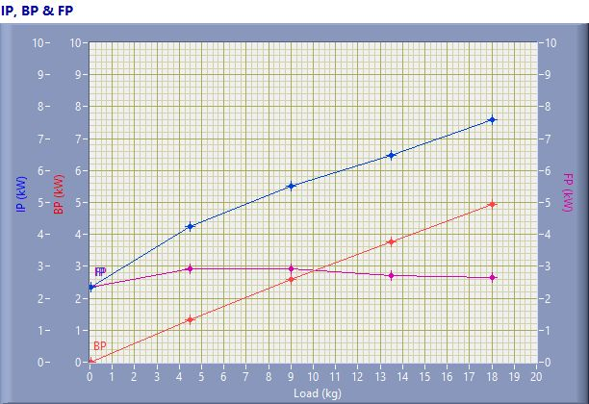

IP, BP & FP

Speed (rpm) | Load (kg) | IP (kW) | BP (kW) | FP (kW)
1556.00 | 0.03 | 2.35 | 0.01 | 2.34
1544.00 | 4.50 | 4.25 | 1.32 | 2.93
1512.00 | 9.02 | 5.52 | 2.59 | 2.93
1467.00 | 13.50 | 6.48 | 3.76 | 2.72
1439.00 | 18.02 | 7.58 | 4.93 | 2.65

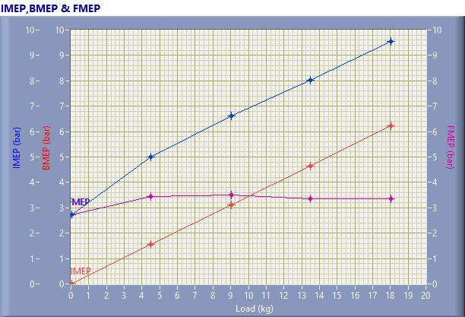

IMEP,BMEP & FMEP

Speed (rpm) | Load (kg) | IMEP (bar) | BMEP (bar) | FMEP (bar)
1556.00 | 0.03 | 2.73 | 0.01 | 2.72
1544.00 | 4.50 | 5.00 | 1.55 | 3.45
1512.00 | 9.02 | 6.62 | 3.11 | 3.51
1467.00 | 13.50 | 8.02 | 4.66 | 3.36
1439.00 | 18.02 | 9.55 | 6.21 | 3.34

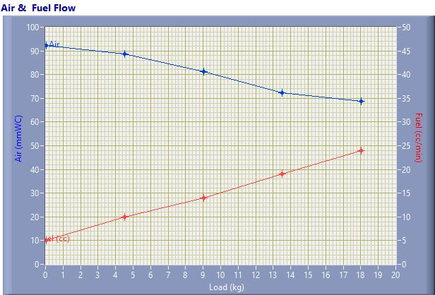

Air & Fuel Flow

Speed (rpm) | Load (kg) | Air (mmWC) | Fuel (cc/min)
1556.00 | 0.03 | 92.24 | 5.00
1544.00 | 4.50 | 88.61 | 10.00
1512.00 | 9.02 | 81.35 | 14.00
1467.00 | 13.50 | 72.29 | 19.00
1439.00 | 18.02 | 68.81 | 24.00

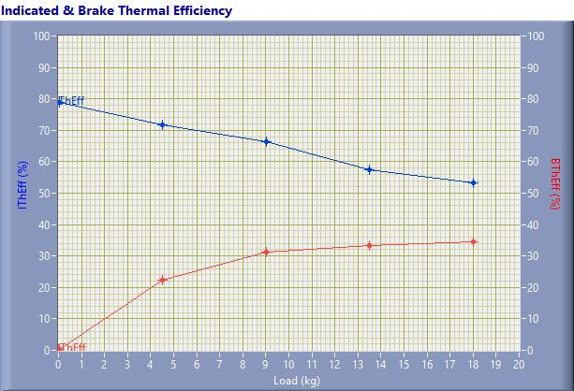

Indicated & Brake Thermal Efficiency

Speed (rpm) | Load (kg) | IThEff (%) | BThEff (%)
1556.00 | 0.03 | 78.98 | 0.32
1544.00 | 4.50 | 71.58 | 22.25
1512.00 | 9.02 | 66.39 | 31.18
1467.00 | 13.50 | 57.46 | 33.36
1439.00 | 18.02 | 53.16 | 34.58

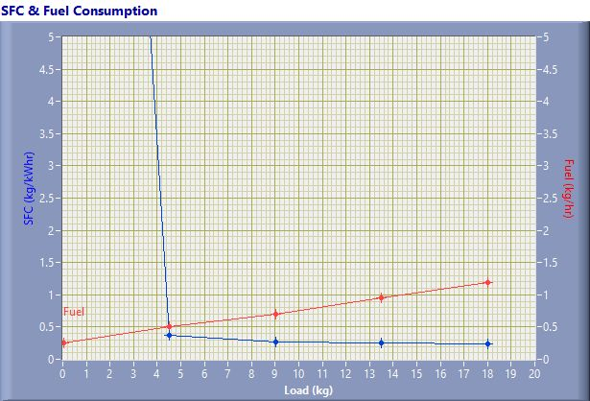

SFC & Fuel Consumption

Speed (rpm) | Load (kg) | SFC (kg/kWh) | Fuel (kg/h)
1556.00 | 0.03 | 26.34 | 0.25
1544.00 | 4.50 | 0.38 | 0.50
1512.00 | 9.02 | 0.27 | 0.70
1467.00 | 13.50 | 0.25 | 0.95
1439.00 | 18.02 | 0.24 | 1.20

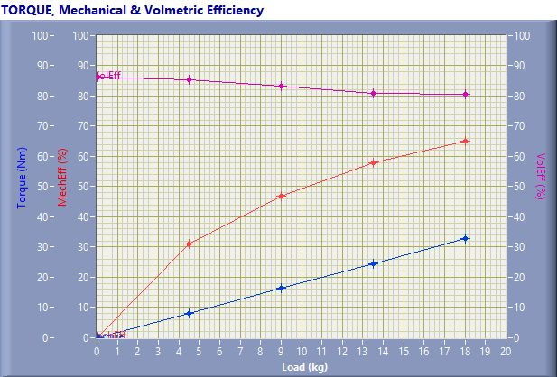

TORQUE, Mechanical & Volmertic Efficiency

Speed (rpm) | Load (Kg) | Torque (Nm) | Mech Eff. (%) | Vol Eff. (%)
1556.00 | 0.03 | 0.06 | 0.40 | 86.29
1544.00 | 4.50 | 8.17 | 31.08 | 85.23
1512.00 | 9.02 | 16.37 | 46.96 | 83.40
1467.00 | 13.50 | 24.50 | 58.06 | 81.02
1439.00 | 18.02 | 32.71 | 65.05 | 80.59

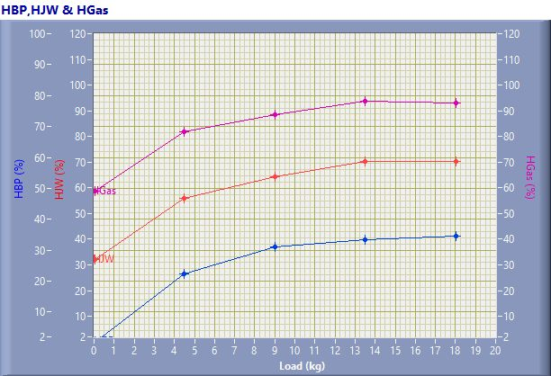

HBP,HJW & HGas

Speed (rpm) | Load (kg) | HBP (%) | HJW (%) | HGas (%) | HRad (%)
1556.00 | 0.03 | 0.32 | 31.68 | 26.70 | 41.30
1544.00 | 4.50 | 22.25 | 33.55 | 26.20 | 18.00
1512.00 | 9.02 | 31.18 | 32.97 | 24.28 | 11.56
1467.00 | 13.50 | 33.36 | 37.06 | 23.17 | 6.41
1439.00 | 18.02 | 34.58 | 35.72 | 22.65 | 7.05

Observation Data

Speed (rpm) | Load (kg) | Comp Ratio | T1 (deg C) | T2 (deg C) | T3 (deg C) | T4 (deg C) | T5 (deg C) | T6 (deg C)
1556 | 0.03 | 17.50 | 38.99 | 43.02 | 38.99 | 37.10 | 109.29 | 92.13
1544 | 4.50 | 17.50 | 39.10 | 47.63 | 39.11 | 38.95 | 190.47 | 151.22
1512 | 9.02 | 17.50 | 39.14 | 50.89 | 39.15 | 40.63 | 246.75 | 193.21
1467 | 13.50 | 17.50 | 39.39 | 57.31 | 39.40 | 43.93 | 325.85 | 254.43
1439 | 18.02 | 17.50 | 39.45 | 61.27 | 39.46 | 45.68 | 401.58 | 304.88

Observation Data

Air (mmWC) | Fuel (cc/min) | WaterFlow Engine (lph) | WaterFlow Cal (lph)
92.24 | 5.00 | 200 | 100
88.61 | 10.00 | 200 | 100
81.35 | 14.00 | 200 | 100
72.29 | 19.00 | 200 | 100
68.81 | 24.00 | 200 | 100

Result Data

Torque (Nm) | BP (kW) | FP (kW) | IP (kW) | BMEP (bar) | IMEP (bar) | BTHE (%) | ITHE (%) | Mech Eff. (%)
0.06 | 0.01 | 2.34 | 2.35 | 0.01 | 2.73 | 0.32 | 78.98 | 0.40
8.17 | 1.32 | 2.93 | 4.25 | 1.55 | 5.00 | 22.25 | 71.58 | 31.08
16.37 | 2.59 | 2.93 | 5.52 | 3.11 | 6.62 | 31.18 | 66.39 | 46.96
24.50 | 3.76 | 2.72 | 6.48 | 4.66 | 8.02 | 33.36 | 57.46 | 58.06
32.71 | 4.93 | 2.65 | 7.58 | 6.21 | 9.55 | 34.58 | 53.16 | 65.05

Result Data

Air Flow (kg/h) | Fuel Flow (kg/h) | SFC (kg/kWh) | Vol Eff. (%) | A/F Ratio | HBP (%) | HJW (%) | HGas (%) | HRad (%)
31.28 | 0.25 | 26.34 | 86.29 | 125.46 | 0.32 | 31.68 | 26.70 | 41.30
30.66 | 0.50 | 0.38 | 85.23 | 61.48 | 22.25 | 33.55 | 26.20 | 18.00
29.37 | 0.70 | 0.27 | 83.40 | 42.08 | 31.18 | 32.97 | 24.28 | 11.56
27.69 | 0.95 | 0.25 | 81.02 | 29.23 | 33.36 | 37.06 | 23.17 | 6.41
27.01 | 1.20 | 0.24 | 80.59 | 22.57 | 34.58 | 35.72 | 22.65 | 7.05

